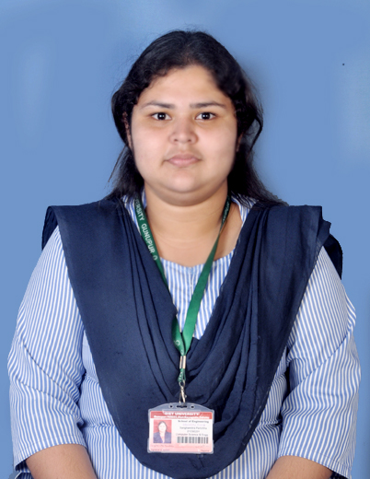

Name: Sanghamitra Parichha
Branch: COMPUTER SCIENCE ENGINEERING
Email: sanghamitraparichha28@gmail.com
Phone: +91 6371121289

Career Objective:
A very Passionate and enthusiastic student looking for an organization which can help me to become the best version of myself by giving me an opportunity where I can showcase my technical skills and enhance the productivity of the organization.
Educational Qualifications:
Degree and Year | Institute | Specialization | Marks/CGPA
B. Tech (CSE) | Gandhi Institute of Engineering and Technology |  | 6.75 CGPA
+2 Science in 2021 | Narayana jr. college | Andhra state board | 8.0 CGPA
10th in 2018 | St Joseph English Medium School | 10th in 2018 | 67.37%

Training / Certification:
- Completed workshop on BASICS FUNDAMENTALS OF KOTLIN By Android&IOT Club.
- Workshop on GUI with python By DATASCIENCE Club Completed Successfully.
- 7 DAYS BOOTCAMP ON HOTSTAR CLONE USING HTML, CSS AND BOOTSTRAP BY DEVTOWN.
- 7 DAYS BOOTCAMP ON SERVER AUTHENTICATION USING EXPRESS AND NODEJS BY DEVTOWN.
- Completed the session for attending INFO Session on jetpack compose.

ADDITIONAL ACTIVITIES:
Student girl coordinator for NSS UNIT of GIET UNIVERSITY.
Conducted spandan program, monthly blood donation camps for NSS unit.

Achievements and Extracurricular activities:
- Best Blood Doner of SRIKAKULAM Dist.
- VOLUNTER FOR NSS at Giet University.

Technical Skills:
- Slide Presentation
- C
- PYTHON
- DBMS
- DATA STRUCTURES
- JAVA

Internship Programs:
RINL (VIZAG STEEL PLANT): A PROJECT BASED ON LABOUR WAGE SYSTEM which was conducted from 05-June-2023 to 01-Jul-2023 and did an interactive project.
Project Details:
Name of the Project | A PROJECT BASED ON FULL STACK WEB DEVELOPMENT
Software Used | Html, CSS, phpMyAdmin, SQL database
Description | Using the above programs the dashboard built on Web Page, we can connect to our browser to see attendance etc... and analyze the working process, work labour wages, locations, and categories, more effective than ever before.

Edu-versity: A PROJECT BASED ON FULL STACK WEB DEVELOPMENT which was conducted through online mode from 15-may-2023 to 30-june-2023.
Project Details:
Name of the Project | A PROJECT BASED ON LABOUR WAGE SYSTEM
Language Used | Python, Java
Description | With the amount of time saved the efficiency and productivity of the employees, the organization increases. The immediate display view of the created form log sheet will contribute to all positive changes.

Personal Details:
Date of Birth | 28-10-2001
Gender | Female
Father's Name | Prakash Chandra Parichha
Mother’s Name | Meera Kumari Parichha
Nationality | INDIAN
Marital Status | Unmarried
Language Known | English, Hindi, Odia, Telugu
Hobbies | Reading stories, Cooking, Singing
Interests | Social working, learning coding

Place: Signature
Date:

